January 2019  Environmental Director- Scott Anderson  Environmental Assistant- Tanya Garner | Tribal Environmental  Newsletter  October 2018  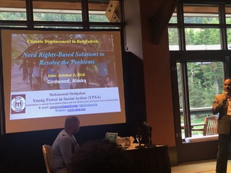  First Peoples Convening  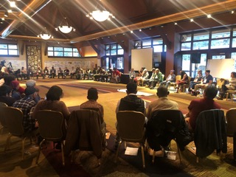  Scott attended the First Peoples Convening Conference in Girdwood Alaska in October 2018. Along with 17 other communities in Alaska, Port Heiden was invited to attend the conference. Topics discussed at the conference included similar situations with climate change and erosion in these communities.  There were also participants from Louisiana, Washington, Bangladesh, Fiji, Kiribati, Papua New Guinea, Marshal Islands, Samoa, Solomon Islands and Tuvalu.
- Contact Us  Tribal Environmental  2200 James Street  Port Heiden, Alaska 99549  Native Village of Port Heiden - (907) 837 2296  Scott – (907) 240 6932  Scott@portheidenalaska.com  Joshua@portheidenalaska.com  Nativevillageofportheiden.com | November 2018  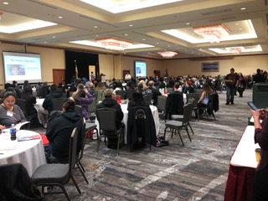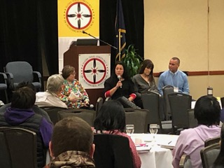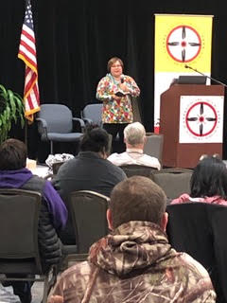  Scott attended the 2018 ATCEM Conference in Anchorage in November. He participated in a few different workshops at the conference, one of them being the VW Environmental Mitigation Settlement. Through the Volkswagen Environmental Mitigation Settlement, federally recognized tribes can apply for funding that would allow for full diesel engine replacements from vehicles made in 1992-2009. About $55 million will be dispersed over 4 years to all 573 federally recognized tribes to help replace/repower any of the following:  - Class 8 / Port Drayage Trucks  - Class 4 – 8 School Buses, Shuttle buses, and Transit Buses  - Ferries, Tugboats  - Ocean Going Vessels  - Class 4 – 7 Local Freight Trucks  - Forklifts  Most vehicles must be 1992-2009  December 2018  Scott purchased a wood pellet stove along with a pellet mill and a hammer mill in early 2018. This pellet burning system produces very little ash or smoke and distributes heat evenly through a forced-air system. It is ultimately a more efficient source of heat that typically requires a single load of wood pellets a day, and provides an economical advantage of eliminating the transportation costs of fuel.  As part of the pellet-making process, wood material must be chipped into small pieces with a wood chipper. A building (Pellet House pictured below, top right corner) is being constructed next to the Recycle Center using recycled or used material.  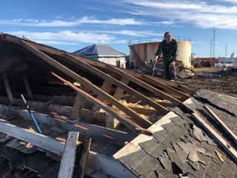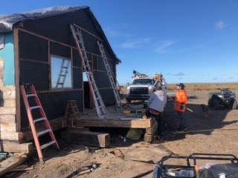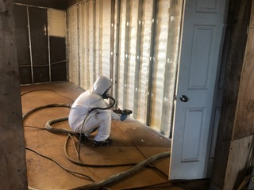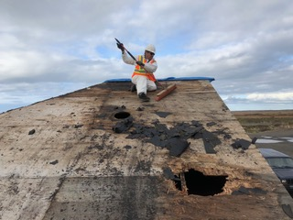  Various IGAP projects  Picture 1- (Top left)  Picture 2- (Top Right)  Picture 3- (Bottom Left)  Picture 4- (Bottom Right)

